# Uninstall procedure

## Component uninstall

Most of the components have an “uninstall” option, this can help when you want to retry that component installation process.

Please note that there are some dependencies between the components, so not all the time you’ll be able to re-install a specific component if you didn’t uninstall some others as well.

Dependencies:

1. Vcenter – doesn’t have an uninstall command, but if you just manually delete the vcenter vm, you might be stuck with VDS configured on the hosts, and sometimes only re-deploy of the hosts might resolve that.
2. ScaleIO – the uninstall of scaleiO will fail if you have some VMs that are using the SIO datastore. You should first uninstall all of the other components (NSX, VCD, vLOG, vROPS, Nagios, Versa).
3. vCD – won’t be able to finish the setup step if the NSX was not deployed and configured first. So when uninstalling NSX, make sure you uninstall vCD before redeploying both.
4. Onrack - doesn’t have an uninstall command, if you are ready to run it again, you’ll need to delete the hosts from the Resource Manager client first.  
   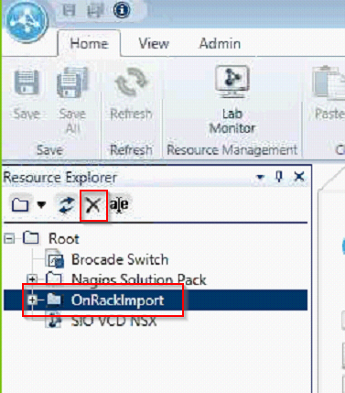

## Full uninstall process

1. First, uninstall the following components if they were already deployed, using their uninstall command:  
   a. Nagios – first, stop the Nagios monitoring, from the NagiosServer component, stop the Start command. Then from the Nagios Monitoring component, run the uninstall command.

b. vCloud Director, NSX, Versa, vLog Insight, vROPS – run the uninstall command of each component – the order doesn’t matter.

c. ScaleIO – now that all the other vms are uninstalled, run the uninstall command of ScaleIO.

d. Remove the onrack discovered resources from the resource manager client as shown above.

d. Uninstall vcenter as described in the next steps.

1. Configure the brocade switch using the “PreSet Brocade” command
2. Remove Master host from the “data” VDS:

Host/Configuration/Networking/vSphere Distributed Switch  
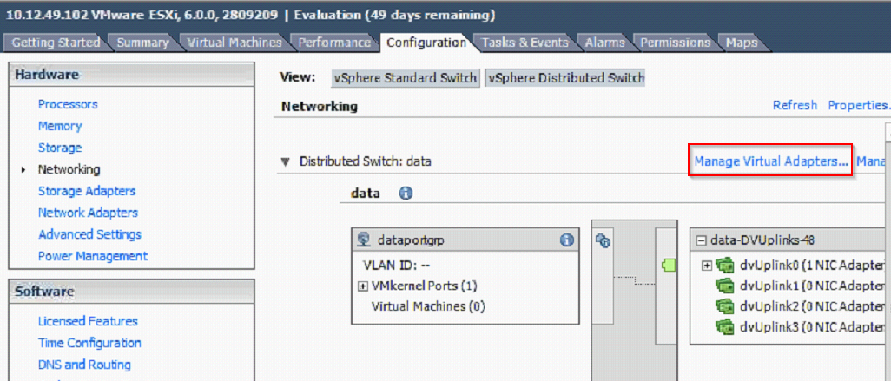

Select vmk1 and remove it  
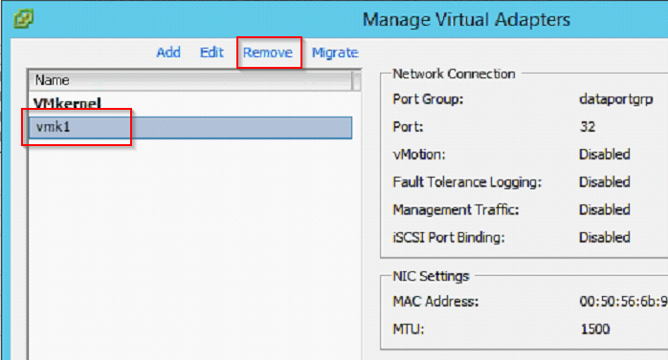

Open the inventory/networking/data/hosts view and remove the master host from the vds:

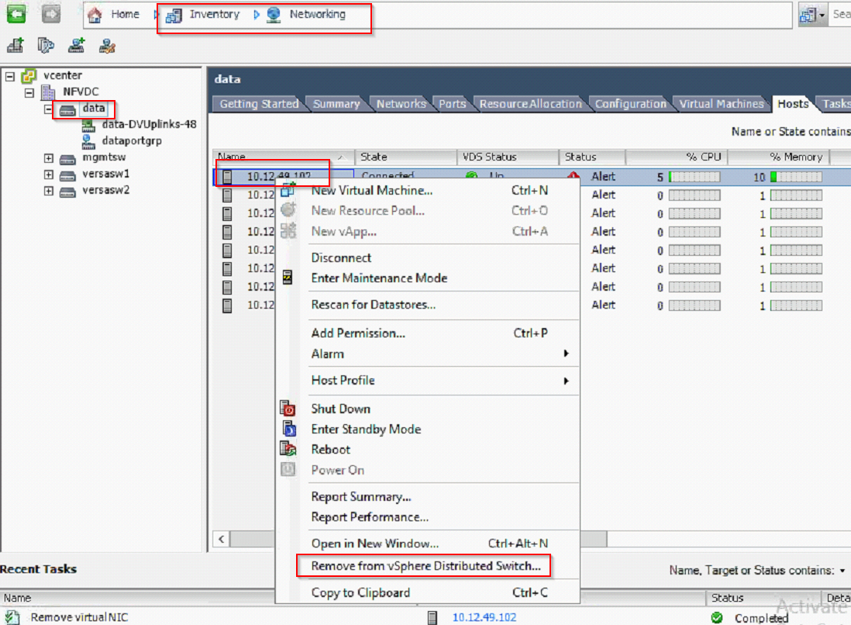

1. Create a new vSwitch0 on the Master host

Host/configuration/networking/vSphere Standard Switch – add networking

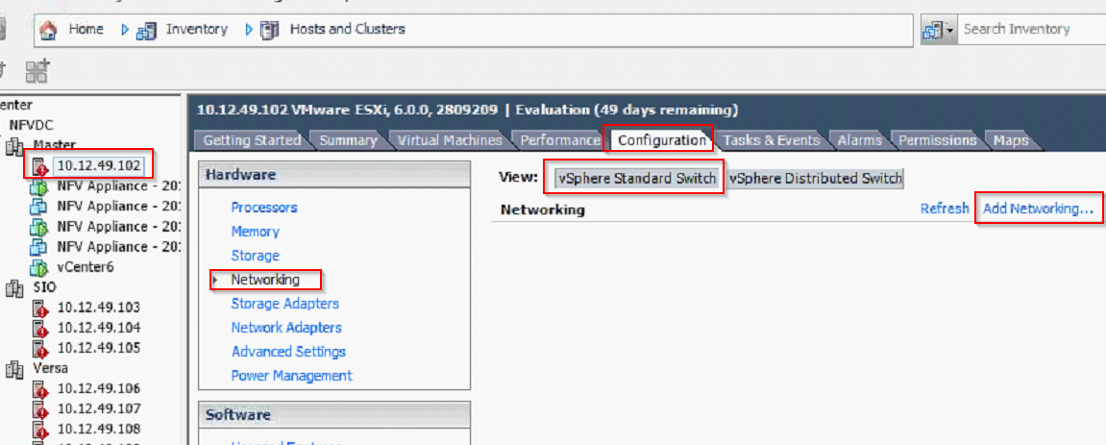

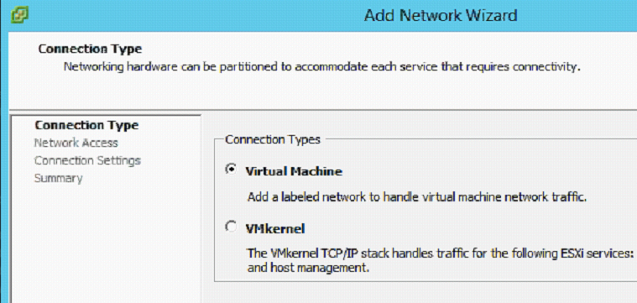

Select vmnic1 (if that’s the port that is configured for use as a secondary port)  
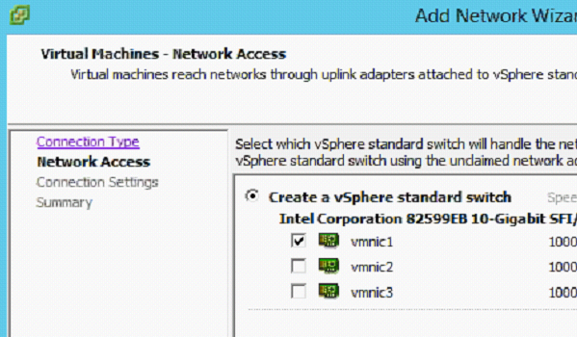

Network label: VM Network  
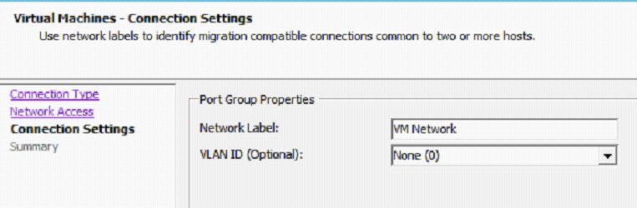

1. Migrate vmk0 to vswitch0

Host/configuration/networking/vSphere Distributed Switch – mgmtsw – Manage virtual adapters  
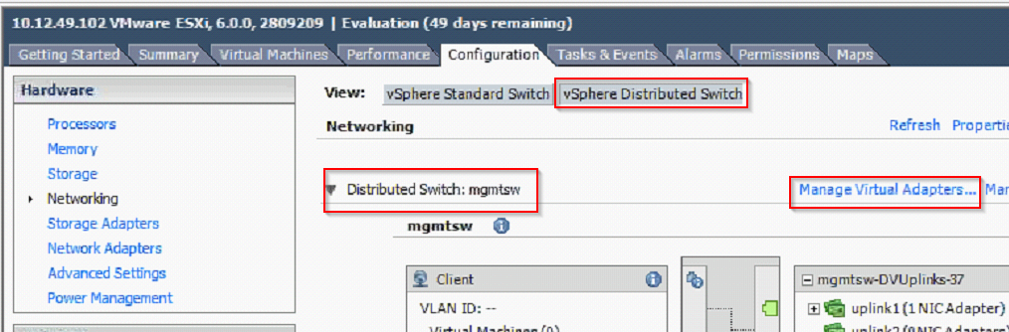

Select vmk0, migrate  
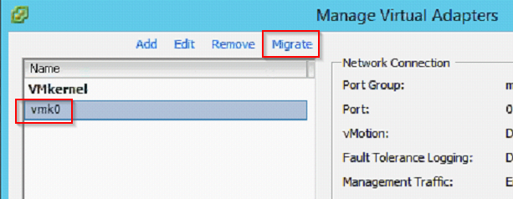

Select vswitch0 (only option)

Network label: VMkernel  
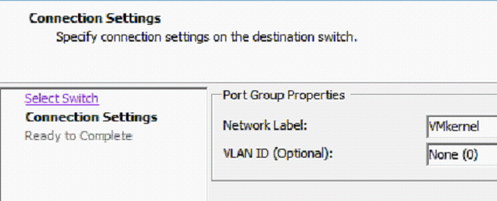

1. Move existing VMs to the vswitch  
   on each vm (vcenter at the end), edit settings, network, change from mgmtportgrp to VM Network  
   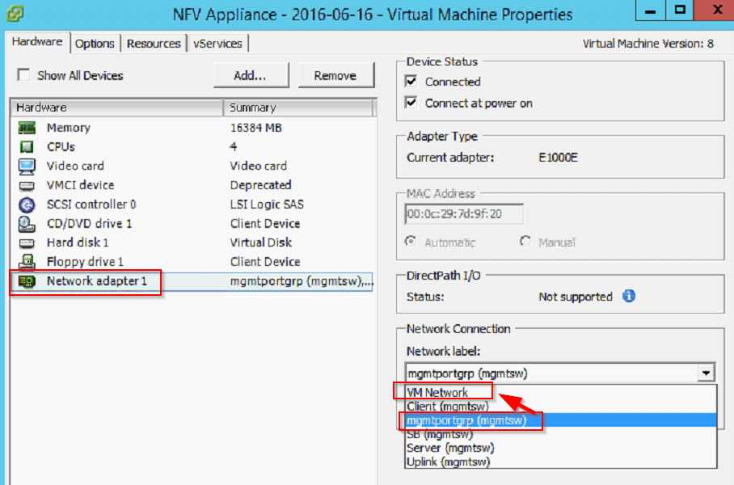
2. Remove vmnic0 from mgmt vds

Host/configuration/networking/vSphere Distributed Switch – mgmtsw – Manage physical adapters  
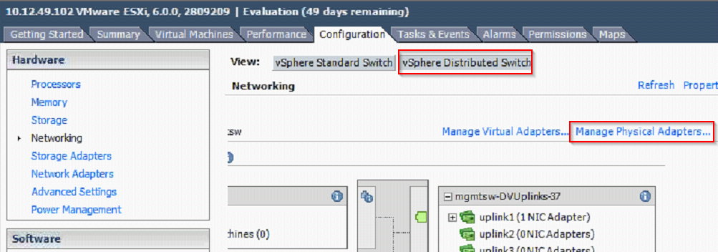  
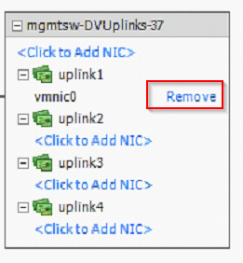

1. Add vmnic0 to vswitch0  
   Host/configuration/networking/vSphere Standard Switch – vSwitch0 properties  
   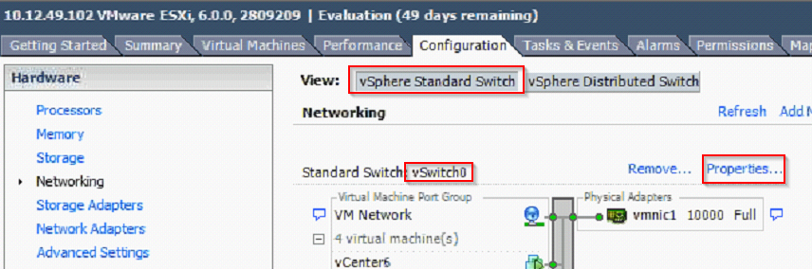

Network adapters tab – Add...  
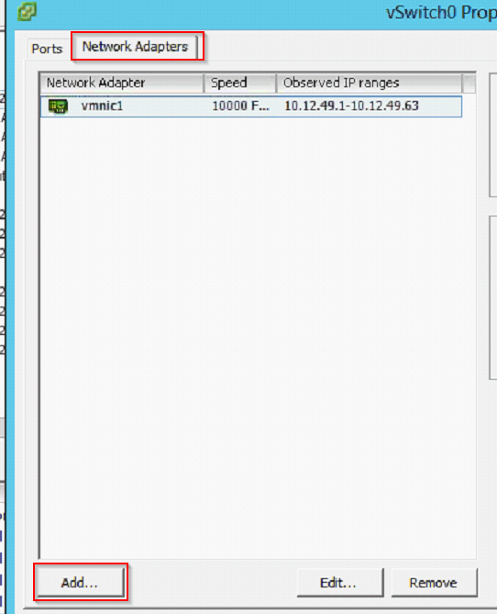

Select vmnic0 (next, next, finish)  
once back in the list, remove vmnic1  
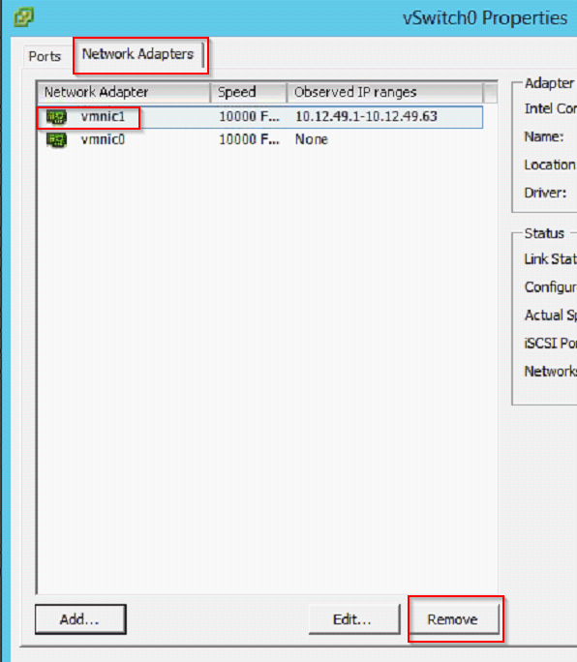

1. Remove the host from the mgmt. vds  
   Open the inventory/networking/data/hosts view and remove the master host from the vds:  
   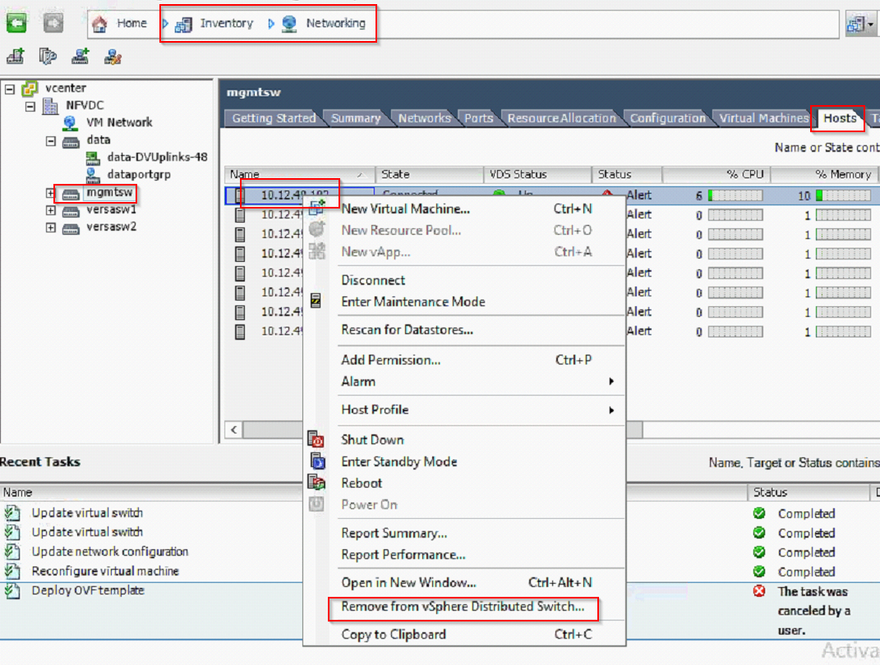
2. Make sure that the master host is not in the vds anymore  
   Host/configuration/networking/vSphere Distributed Switch – should be empty  
   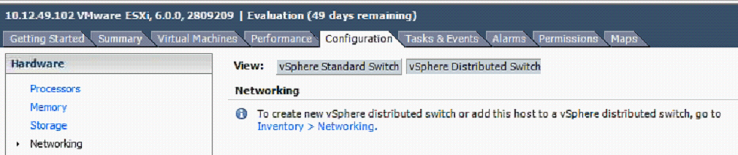
3. Now it is safe to delete the vcenter vm (should be done from the vsphere client connect to the master host).